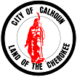

SPECIAL CALLED
CITY COUNCIL MEETING
OCTOBER 7, 2025 – 1:00 PM
700 WEST LINE STREET
CITY HALL CONFERENCE ROOM

AGENDA
- Called to order and welcome -Mayor Palmer

- Motion to move to Executive Session – Personnel

- Motion to return to General Session

- Motion to Adjourn

